MANUAL TO ADD DATASET

Things required: -
- Total number of files combined in all the database. Even if this is not known, lower limit should be known. Example, if total number of files combined in all database is 12945, a number greater than 12945 should be entered say 13000. So, basically a rough idea of lower limit should be known. Although any large number can be entered, please enter a suitable number. This will help in not causing unnecessary space usage problems.
- Path of the csv folder of the dataset. Ensure that this folder only contains files relevant to csv co-ordinates.
- Path of the database txt file which contains energy and file name information.
- Size of MgCl2 cluster to be used. (e.g. 19 or 20 or 30)
- Number of datasets to be added. Example, if datasets of 19,20 and 30 MgCl2 are to be added for training, enter 3.
- I will be sending two python files. However, only one of them has to be run. However, both the files need to be in the same folder. Also, the ‘model.Pickle’ file will be created on its own (that is the file which contains exported model)
For now, I have built the source code such that at the start user has to input various inputs. Thus, it may be a bit tedious, however, this is done so that order of inputting is not messed up.

To explain how to add datasets and create a model
Firstly, there are two python files required-
1. dataset_add.py
2. read_data.py
However, only dataset_add.py needs to be run. However, read_data.py also need to be in same folder as dataset_add.py

We see below how the file gets executed.
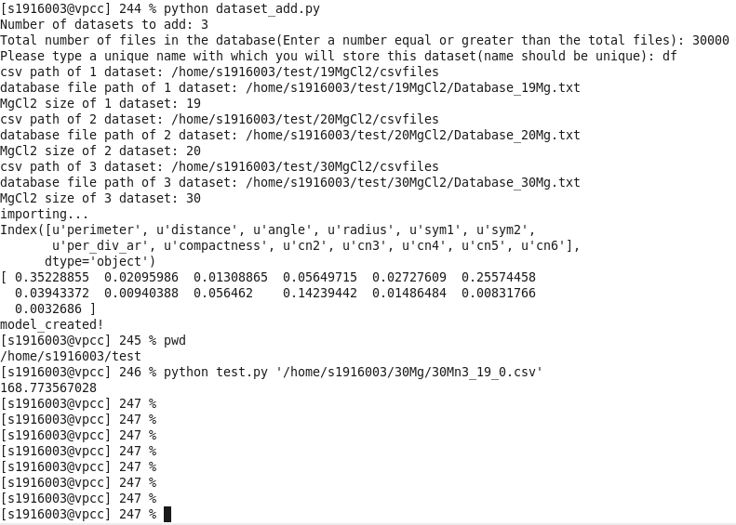
First enter number of different datasets to be added. (here, 3 since ,19,20 and 30 Mg are added)
Next enter total combined files. (here, files were less than 30,000 so it is a valid entry)
Next enter a name for the model (keep this unique, since it should be different name from other datasets added)
Other entries are self-explanatory.
Finally, if successful, “model_created” will be displayed.

Two folders will be created
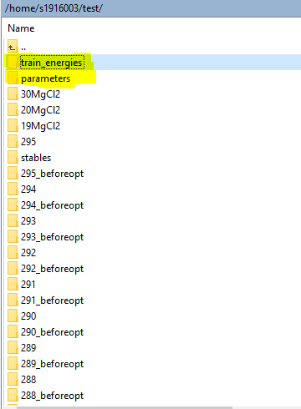
These are highlighted as shown.
train_energies contains the energies of the files (train data) for the various models created.
For e.g. in above case it stores df
parameters contain various calculated features. It will also contain similar file name (i.e. df)

So, these folders are important since sometimes if you want to only create model from selected datasets.
Example:
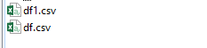
If another dataset is added (similar to df1 as done above). Now suppose model is only to be created from df.csv
In this case, delete df1.csv from both parameters and energy folder, then run the read_data.py

However, in most cases, this is generally not required. So, in general, just run dataset_add.py to add datasets as shown. When all added, run test.py.
This is useful in a way that if suppose model is created for 19,20 and 30. Then suppose model for 40 and 50 Mg is to be added. Just run the code for 40 and 50, and not for 19,20,30,40 and 50 Mg. This way it becomes easier to add just the new dataset.

Note: Just ensure that in folders parameter and energy, same number of files and with same filename are present

